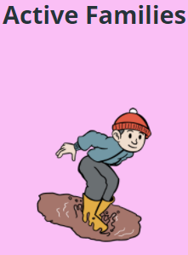
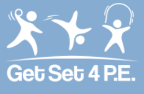
Get Set 4 P.E – Physical Ideas
Choose an activity by double clicking on one of the file links below.
BALLOON CHALLENGE | CLOCK FACE | DANCE EXPRESS | JUGGLING | JUST DANCE
OBSTACLE COURSE | TARGET PRACTISE | THE 100 GAME | THROUGH THE GAP | WORD ASSOCIATION
ADD IT ON | FIND THREE THINGS THAT ARE... | GET DANCING! | HAMSTER WHEEL | HIDE AND SEEK
NEWSPAPER DANCE | SARDINES | BALLOON VOLLEYBALL | BOTTLE SKITTLES | HIT IT TO WIN IT
KICK ROUNDERS | MOUSETRAP | PLANE IN FLIGHT | RALLY | ROLLER BALL
SOCK BOULE | SOCKS IN POTS | SPELL IT OUT | SQUAT AND SHOOT | 10-1 WORKOUT

