- Search for Microsoft TEAMs in a search engine.
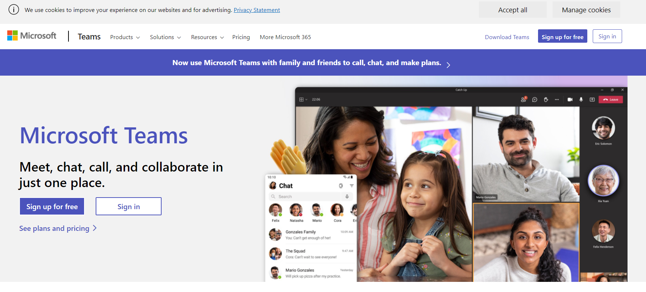
- Sign in using the details given to you for your child.
For Years 1 – 6 It should take this format:
Email: Firstname.lastname@southview.lincs.sch.uk
Password: date of birth + first initial + last initial
e.g. John Smith has his birthday on 2nd February so his log in details would be
Email: john.smith@southview.lincs.sch.uk
Password: 02js
EYFS will use Tapestry.

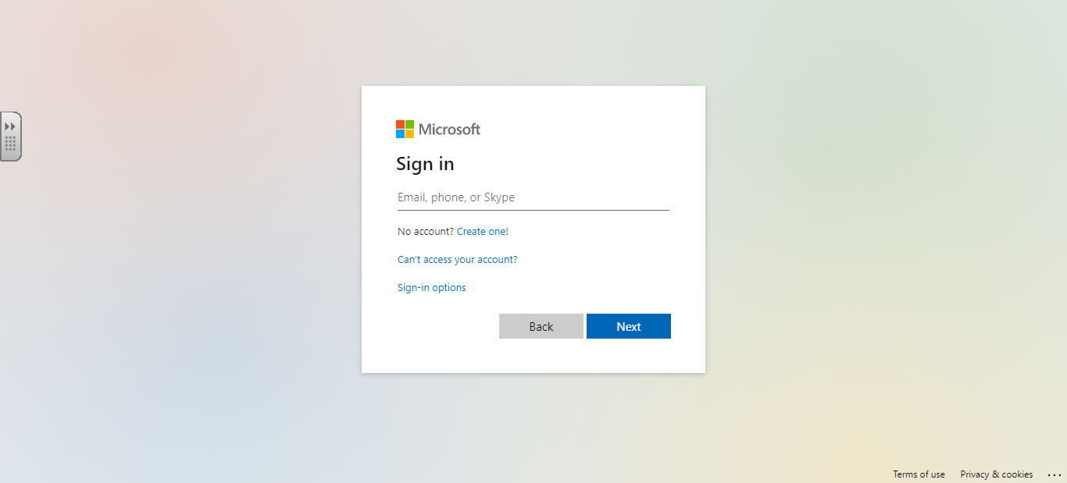

- Click on ‘use the web app instead’
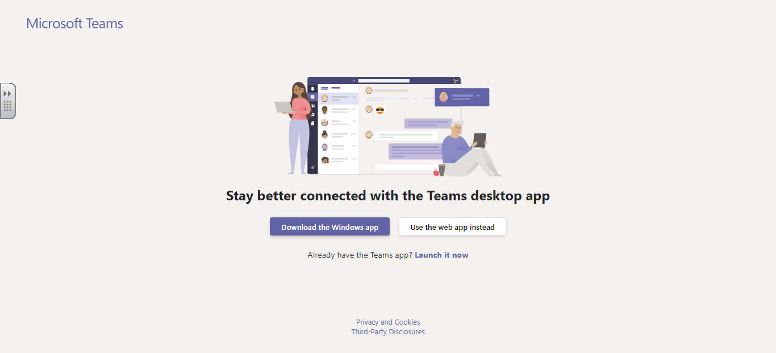
- When Microsoft Teams opens, in your class team, go to ‘Assignments’ and see what work has been set for you to do that day.
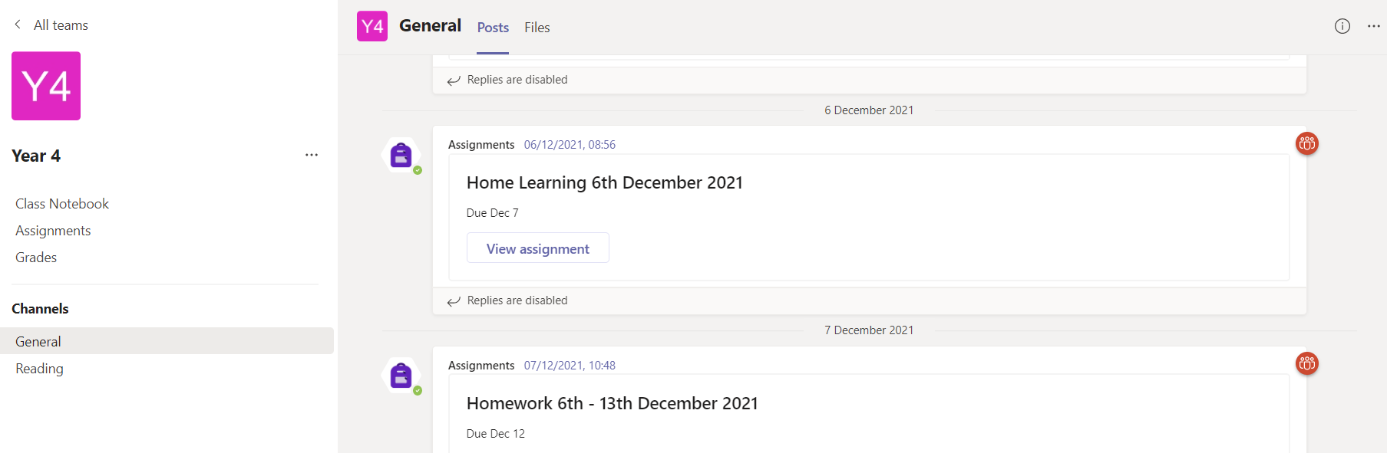

- Follow the instructions that have been given to you by your class teacher. In this example you have been asked to watch a video and then complete a worksheet. Click the link or copy and paste the link into a tab to watch the video.
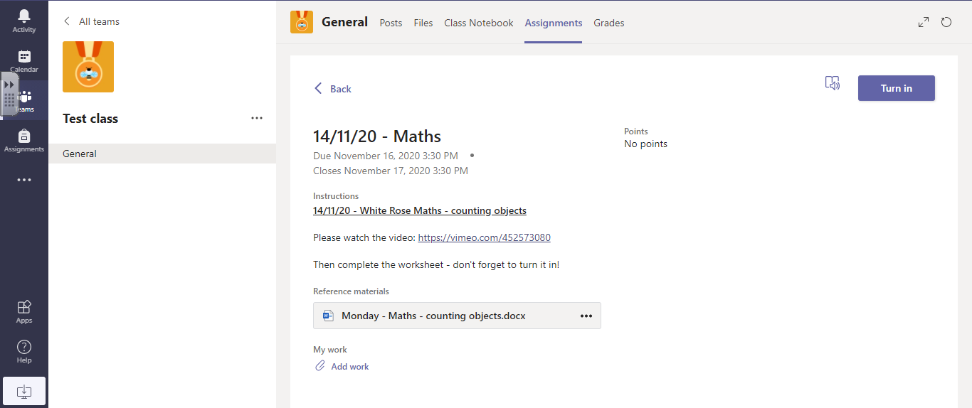
- When you are ready to complete the worksheet or form link.
If your teacher has created a Microsoft form for you to complete, click on the form link. This will open the worksheet. (once you have finished press submit at the bottom)

For worksheets follow the next steps. Click on the three dots on the right-hand side of the worksheet and choose ‘open in word online’.
- Read the questions and write your answers in the answer boxes
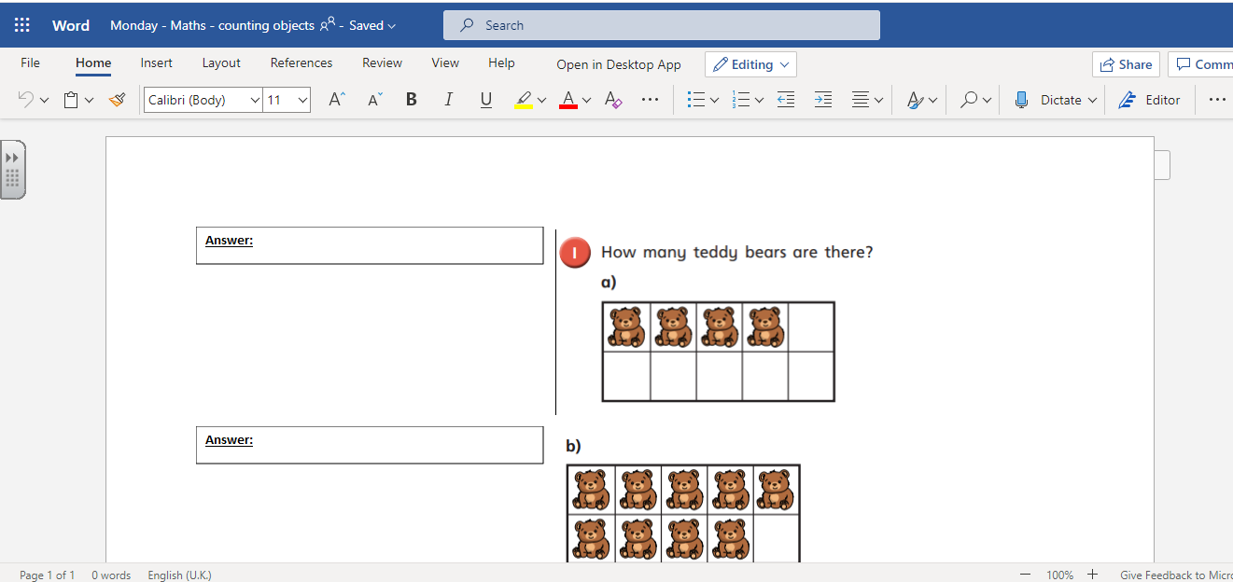

- When you have completed the task press the save icon in the top left corner and close the document.

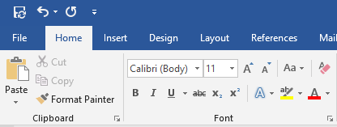

- Finally, press ‘turn it in’. Your teacher will mark your work and send it back to you with comments.
NB. If you have done something extra, that would like to add, add this in using the ‘add work’ button.
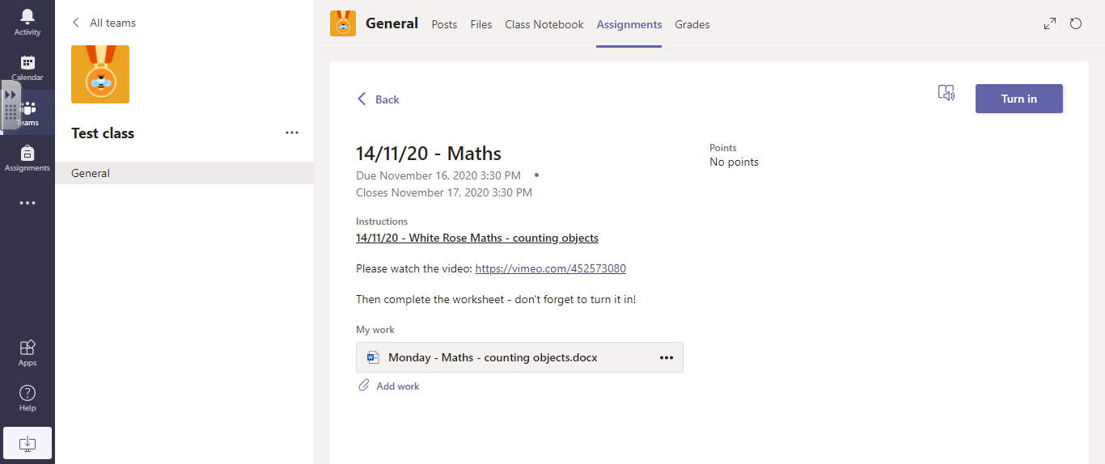

- When your teacher has read your work and given you feedback, you can find this in the ‘completed’ section of the ‘Assignments’ tab in Microsoft Teams.

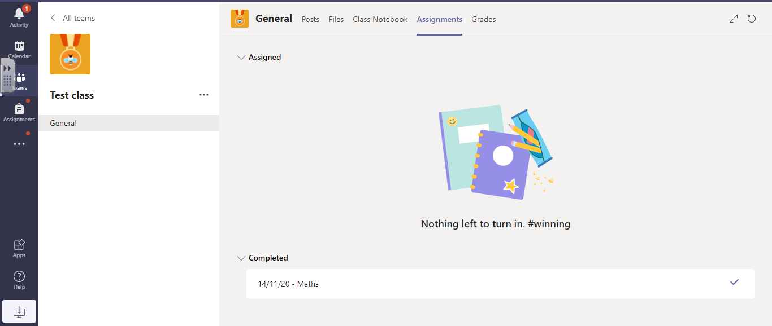
- Your feedback is on the right-hand side of the screen. If you need to have another look at something and resubmit it, follow the procedure from step 7 again and once you are happy, press ‘turn in again’.
