Subject Leader: Harry Ford

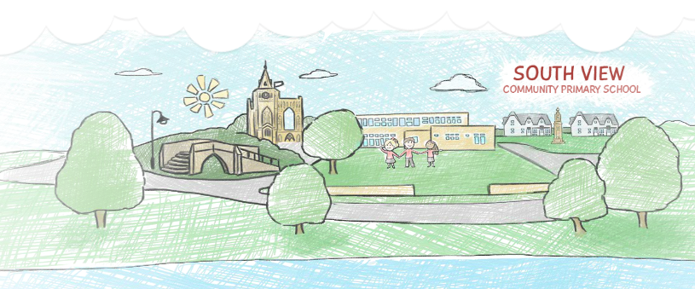
South View Community Primary School

Our PSHE and RSE Curriculum

Contents | PAGE
1. The Basic Principles of Our Curriculum | 3
2. Our Curriculum Intent | 3
3. PSHE and RSE Intent | 4
4. PSHE and RSE Implementation | 7
5. Meeting the needs of all pupils in PSHE and RSE  (SEND and Greater Depth) | 8
6. PSHE and RSE Scheme of Work - Long Term Plan  (including curriculum and Learning Objectives) | 16
7. Assessment | 28
8. PSHE and RSE Impact | 29
9. Relationships and Sex Education | 30

THE BASIC PRINCIPLES OF OUR CURRICULUM

Learning is a change to long term memory.
Our aims are to ensure that our children experience a wide breadth of study and have, by the end of each Key Stage, long -term memory of an ambitious body of procedural and semantic knowledge.

OUR CURRICULUM INTENT
Curriculum Drivers shape our curriculum breadth. They are derived from an exploration of the backgrounds of our children, our beliefs about high quality education and our values. They are used to ensure we give our children appropriate and ambitious curriculum opportunities. Our curriculum drivers, enabling us to ensure OUR children get what THEY need from us are that:
- Our children will develop vocabulary so that they are able to speak and understand spoken language, access more complex texts and write with eloquence.
- Our children will leave South View as successful readers. They will 'learn to read' and consequently 'read to learn'.
- Our children will explore their own cultures, surroundings and emotions and those of others, to gain a wider understanding of the world and their place within it.

PSHE and RSE Intent
The overarching aim for PSHE education is to provide pupils with accurate and relevant knowledge with opportunities to turn that knowledge into personal understanding. There are also opportunities to explore, clarify and if necessary challenge their own and others values, attitudes, beliefs, rights and responsibilities. The skills and strategies they need in order to live healthy, safe fulfilling, responsible and balanced lives are also taught.
At South View Community Primary School, we aim for our lessons to be accessible to all and ensure that each of our children will know more, remember more and understand more about how to play a positive and successful role within our society, both as a child and as future adults. Our aim is to provide children with a knowledge of their world, locally, nationally and globally and give them confidence to tackle many of the moral, social and cultural issues that are part of growing up within this.
Our ambition is to give all children the opportunities to learn about rights and responsibilities and appreciate what it means to be a member of a diverse society. Moreover, our pupils are encouraged to develop their sense of self-worth by playing a positive role in contributing to school life and the wider community. We offer our children leadership opportunities within the school and their local community.
We develop the following characteristics in our children:
- Spiritual, moral, cultural, mental and physical development which occurs in school and carries them through their future lives
- Readiness for the opportunities, responsibilities and experiences of later life
- The ability to ask questions and discuss issues freely while feeling safe and without embarrassment
- Pupils who are happy to explore, clarify and if necessary challenge their own and others values, attitudes, beliefs, rights and responsibilities
- The skills and strategies to be able to live healthy, safe fulfilling, responsible and balanced lives

Teaching Approaches:
- Create a caring environment where pupils feel safe and are listened to
- Provide opportunities for discussion and exploration of knowledge, skills and attitudes through circle time, paired or small group work, whole class discussion, brainstorming, drama and role play, use of puppets, the ‘draw and write’ approach and the use of stories
- Complement lessons based on the PSHE Associations Thematic Scheme of work by the use of other resources such as: factual information provided by staff; videos relevant to themes; computer programs which provide information, illustrate themes or stimulate discussion; talks by visiting professionals.
External providers: South View does not routinely use external providers to deliver PSHE, Relationships Education or Sex Education. Where an external provider is used, the school retains responsibility for content and delivery. Provision and resources will be checked in advance to ensure they are accurate, age-appropriate, inclusive, evidence-informed, consistent with this guidebook, the school's PSHE & RSE Policy and DfE statutory guidance, and appropriate to safeguarding arrangements. The school will quality-assure the provider and inform parents/carers where significant external provision forms part of the programme.

Key Strand: Curriculum – Intent
- Our PSHE and RSE curriculum inspires an understanding and passion for individuals to lead a healthy lifestyle.
- Our PSHE and RSE curriculum helps to foster and create a school culture and environment that supports pupil wellbeing and develops resilience and character, holding the pupil’s health and emotional wellbeing at its heart.
- Our PSHE and RSE curriculum equip children in skills of citizenship and to guide them in becoming happy, successful and productive members of society.

Our PSHE curriculum inspires:
- a positive outlook on life and the wider world around them.
- provides children with knowledge, skills and strategies that allow them to become well-rounded citizens with in the community and build positive relationships.

How do we grow well-rounded members of society? (Intent)

PSHE enables our children to become healthy, independent and responsible members of society. It aims to help them understand how they are developing personally and socially, and tackles many of the moral, social and cultural issues that are part of growing up. We provide our children with opportunities for them to learn about rights and responsibilities and appreciate what it means to be a member of a diverse society. Our children are encouraged to develop their sense of self-worth by playing a positive role in contributing to school life and the wider community. We use the PSHE Association Programme of Study as a supporting framework where children develop skills and attributes such as resilience, self-esteem, risk management, team working and critical thinking.
Key 3 aspects I want staff to know:
- At the heart of the PSHE curriculum is for the children to have a good mental wellbeing and be happy.
- The teaching of PSHE should encourage children to build positive and trusting relationships with themselves and others.
- The PSHE curriculum and teaching should enable the children to build their confidence and self-esteem to become confident learners across the curriculum.

Key Strand: Curriculum – Intent –
- Our PSHE and RSE curriculum inspire an understanding and passion for individuals to lead a healthy lifestyle.
- Our PSHE and RSE curriculum helps to foster and create a school culture and environment that supports pupil wellbeing and develops resilience and character, holding the pupils health and emotional wellbeing at its heart.
- Our PSHE and RSE curriculum equip children in skills of citizenship and to guide them in becoming happy, successful and productive members of society.

PSHE and RSE Implementation
At South View Community Primary School, PSHE and RSE is delivered through a clear and comprehensive scheme of work which is in line with the National Curriculum. The scheme of work we’re following is the Kapow Primary's revised RSE & PSHE scheme, adapted to meet the needs of our children.

We’ve worked hard to make sure that our curriculum reflects:
- Our pupils’ age and maturity levels, as well as their cultural and religious backgrounds.
- The values of our school community.
- Every pupil’s learning needs.
- What pupils need to know to be healthy and safe in school, in their personal relationships and in the wider world.
In order to achieve these aims, the scheme of work includes opportunities to link British Values and SMSC into the curriculum. The spiral curriculum starts in EYFS and follows the children through to Year 6. The distribution of the lessons complements key campaigns throughout the year such as Anti-Bullying Week, Science Week and sports events.
PSHE and RSE is also delivered through key stage and class assemblies on a weekly basis. During these assemblies, children’s spiritual, moral, social and cultural curiosity is stimulated, challenged and nurtured.
–27 curriculum update: This guidebook has been reviewed against the revised DfE RSHE guidance effective from 1 September . The existing spiral curriculum and three South View areas—Relationships; Living in the Wider World; Health & Wellbeing—remain in place, with strengthened learning in the areas identified by the school's gap analysis.
Key strengthened areas include healthy boundaries and assertiveness; emotional, physical and sexual abuse, grooming and exploitation; online relationships, privacy, personal data, social-media age restrictions, scams, fraud, gaming monetisation and manipulated content; healthy relationships with food and nutritional information; mental wellbeing; puberty and menstrual wellbeing; basic first aid and head injuries; and nicotine addiction including nicotine pouches.

5. MEETING THE NEEDS OF ALL CHILDREN IN PSHE and RSE
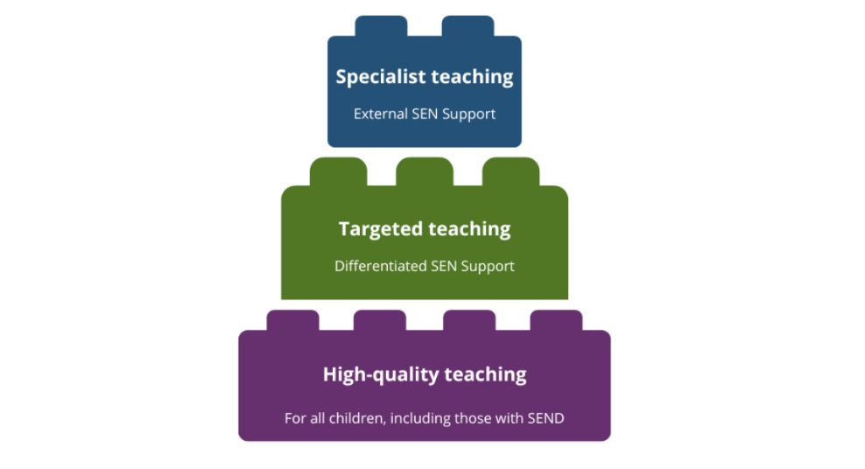
Supporting children with Special Educational Needs and Disabilities.
At South View Community Primary School, we recognise the research of the EEF (2020) and prioritise the development of high-quality teaching, as the most effective intervention for children with SEND.
It is particularly important to capitalise on the opportunities offered by PSHE and RSE for pupils with SEND to develop their own voice and to play an active role in determining their own identities. These opportunities could begin with taking responsibility by taking on class responsibilities, including peer support. They can then be developed through taking part in opportunities such as school democracy, e.g. class and school parliament, and through wider school activity.
In order to make PSHE and RSE lessons inclusive, teachers at South View Community Primary School anticipate what barriers to taking part and learning particular activities, lessons or a series of lessons may pose for pupils with particular SEND. Planning considers ways of minimising or reducing those barriers so that all pupils can fully take part and learn.
High-quality teaching foundation. Adapted from EEF, 2022.
In some activities, pupils with SEND will be able to take part in the same way as their peers.
In others, some modifications or adjustments will need to be made to include everyone.
For some activities, a ‘parallel’ activity for pupils with SEND is put in place, so that they can work towards the same lesson objectives as their peers, but in a different way − e.g. using ICT to present virtual decision-making scenarios where role-play may be difficult for some pupils.
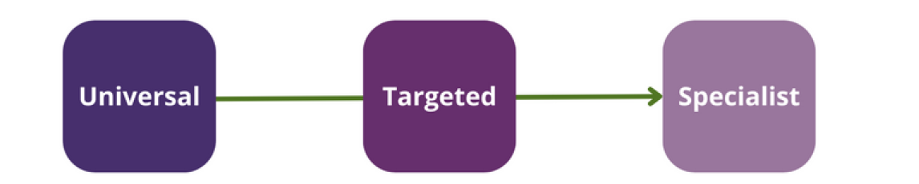
Occasionally, pupils with SEND will have to work on different activities, or towards different objectives, from their peers, depending on their individual needs.
SEND Support.
Adapted from EEF, 2020, p.9

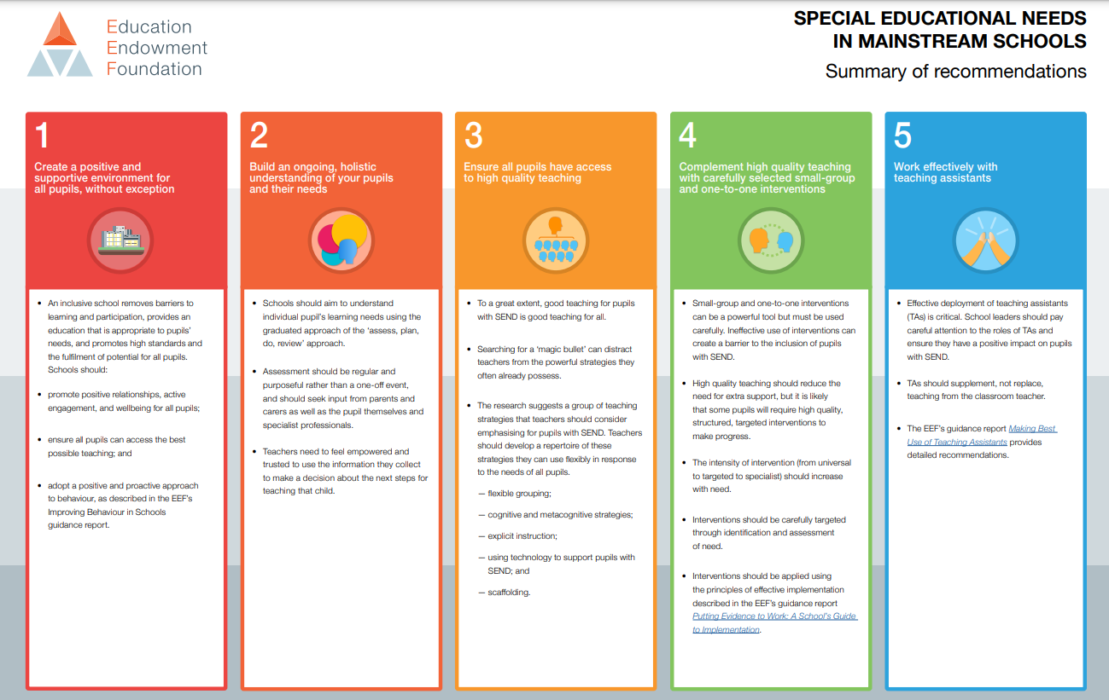

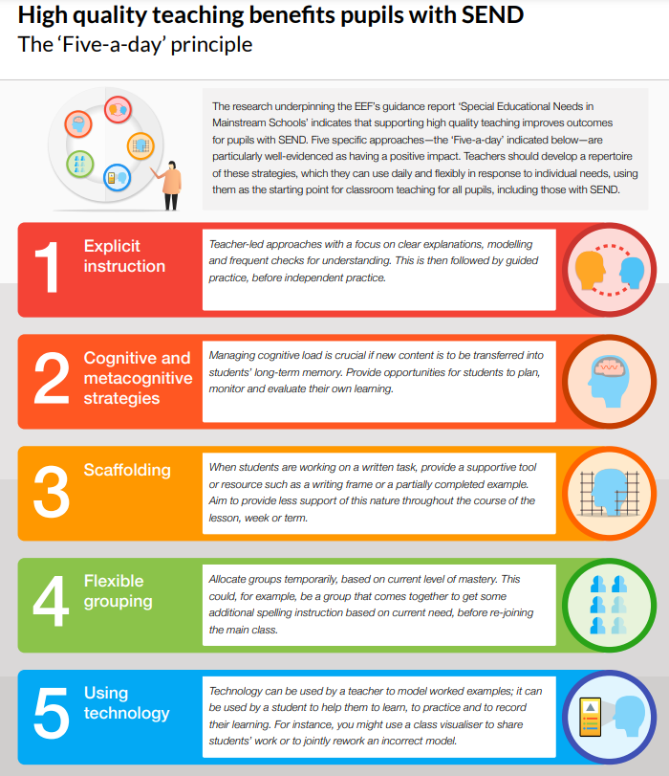

Potential barriers to learning and how these are supported:
Cognition and Learning |  | Communication and Interaction
Subject Challenges for SEND | Provision for SEND | Subject Challenges for SEND | Provision for SEND
Difficulties to remember and retain information, facts, vocabulary or previous learning.  Access to learning due to poor literacy or cognitive skills. | - Spiral Curriculum in place.  - Floor Books used to support recap of prior learning.  - Adaptive PSHE and RSE curriculum materials are used to meet the individual needs and abilities of SEND pupils.  - Differentiated activities and resources to ensure accessibility for all SEND pupils in PSHE and RSE lessons.  - Variety of teaching strategies implemented to cater to different learning needs.  - Support from teaching assistants to access teaching materials. | Difficulties using language or expressing themselves.  Confidence to express ideas and opinions in PSHE and RSE lessons.  Unwilling to discuss sensitive topics covered in PSHE and RSE lessons. | - Clear ground rules set at beginning of each lesson.  - Anonymous box used where appropriate.  - Positive relationships promoting active engagement, and wellbeing for all pupils.  - Safe learning environment.  - Visual aids and charts are provided to support understanding and communication during lessons.  - Allocated time to talk and discuss.  - Sentence starters and modelled language.  - Repetition and use of stem sentences.  - Variety of teaching strategies implemented to cater to different learning needs.  - Opportunities to express ideas in various way- not just verbally.  - Simplified step by step instructions.
Physical and Sensory |  | Social Emotional and Mental Health
Subject Challenges for SEND | Provision for SEND | Subject Challenges for SEND | Provision for SEND
Visual impairments  Hearing impairments  Needing support to record information and/or written work.  Other sensory needs. | - Regular and thorough assessments of the classroom environment in place to identify any physical barriers that may impede access to PSHE and RSE lessons  - Ensure documents are enlarged or provided for individual.  - Magnifier used if necessary.  - Use of alternative communication methods, such as visual aids and sign language, to support students with hearing impairments.  - ICT resources to be used to support children’s needs.  - ICT equipment to be used for recording purposes.  - Talking tins to be used.  - Use of visual aids, tactile resources, and music where necessary. | Pupils who struggle with their confidence and have low self-esteem issues.  Distressed or triggered by specific topics covered in PSHE and RSE. | - Clear ground rules set at beginning of each lesson.  - Anonymous box used where appropriate.  - Positive relationships promoting active engagement, and wellbeing for all pupils.  - Safe learning environment.  - Lessons follow same structure pattern (please see non-negotiables) in order to provide routine.  - Lessons appropriately adapted with clear instruction and scaffolding to ensure lessons are accessible.  - Teachers consider content being used in lessons and liaise with SENDCO if and subject leader if needed.  - Parents are consulted, especially with RSE content or areas which may cause upset.

Non-Negotiables in place for all PSHE and RSE lessons:

Clear ground rules set at the beginning of each lesson.

Prior-learning revisited at the beginning of every lesson.

Key vocabulary explored for understanding throughout teaching.

Assessment for Learning throughout to ensure understanding.

Challenging and Extending Children to achieve Greater Depth
Opportunities for Responsibility Roles
One effective approach at South View Community Primary School is to support greater depth children in PSHE and RSE by offering them opportunities for responsibility roles. By assigning them leadership roles, such as peer mentors or class ambassadors, these students gain the chance to develop and apply their knowledge and skills in a real-world context. This not only enhances their understanding, but also fosters their confidence and sense of ownership over their learning.
Encouraging for Mastery
To support greater depth students in PSHE and RSE, the classroom environment helps to encourage mastery. This is achieved by providing them with challenging tasks and activities that stretch their thinking and allow them to deepen their understanding. For instance, engaging them in debates, discussions or research projects on more complex topics, like ethical dilemmas or healthy relationships, allows them to demonstrate a higher level of analysis and synthesis.
Developing Fluent Knowledge and Good Recall
In order to help greater depth pupils to develop fluent knowledge and good recall in PSHE and RSE, they are provided with a range of opportunities to practice and apply their learning. This can be achieved through regular assessment and revision exercises, such as quizzes, interactive activities, and scenario-based tasks. Additionally, giving them the chance to showcase their knowledge through presentations or group projects further strengthens their understanding and retention of key concepts and information.
Embracing Spiral Curriculum
A spiral curriculum is a key component in supporting greater depth children in PSHE and RSE at South View Community Primary School. By ensuring that learning is designed in a spiral manner, where new concepts and ideas build upon prior knowledge, we provide pupils with continuous opportunities to delve deeper into the subject matter. This approach enables them to make connections, see patterns, and develop a more comprehensive understanding of complex topics, such as identity, consent, and cultural diversity.

Collaborative and Differentiated Learning
At South View Community Primary School in order to meet the needs of greater depth children in PSHE and RSE, a collaborative and differentiated learning approach is used, proving highly beneficial. By encouraging group work and collaborative projects, pupils can engage in in-depth discussions, share perspectives, and learn from one another. Differentiated learning strategies, such as tiered activities or open-ended tasks, ensure that their individual needs are addressed and they are appropriately challenged at their level of ability.
Integration with Other Subjects
Integration of PSHE and RSE with other subjects further supports greater depth students in making connections and deepening their understanding. For instance, in Science, exploring the human body is linked to discussions on consent and wellbeing. This interdisciplinary approach allows greater depth learners to transfer and apply their knowledge across various contexts, enhancing their overall learning experience.

Conclusion
At South View Community Primary School, we believe supporting greater depth children in PSHE and RSE is paramount in order to provide them with the opportunity to flourish academically and personally. By offering them responsibility roles, encouraging mastery, developing fluent knowledge and good recall, embracing a spiral curriculum, promoting collaborative and differentiated learning, and integrating with other subjects, we can ensure that these students are adequately challenged and empowered to deepen their understanding, whilst nurturing their overall development.

PSHE and RSE Scheme of Work - LONG TERM PLAN
EYFS | Year 1 | Year 2 | Year 3 | Year 4 | Year 5 | Year 6
Relationships (Autumn Term)
Families and Friendships
To begin to recognise strategies to build constructive and respectful relationships.  To recognise special people in their life.  To talk about members of their immediate family and community.  To know about the lives of people around them and their roles in society e.g. teachers, firefighters, doctors etc.  To recognise ways to be kind and how to be a good friend to others.  To know who they can talk to if they are worried about something. | To understand the role about people who care for them and the role they play (e.g. parents, siblings, grandparents, relatives’ friends, doctors and teachers.)  To know what it means to be a family and how families are different, e.g. single parents, same-sex parents etc.  To understand about the importance of telling someone — and how to tell them — if they are worried about something in their family. | To recognise how to be a good friend, e.g. kindness, listening, honesty.  To know about the different ways that people meet and make friends.  To develop strategies for positive play with friends, e.g. joining in, including others, etc.  To understand about what causes arguments between friends  To know how to positively resolve arguments between friends.  To know how to recognise, and ask for help, when they are feeling lonely or unhappy or to help someone else. | To recognise and respect that there are different types of families, including single parents, same-sex parents, step-parents, blended families, foster and adoptive parents.  To understand that being part of a family provides support, stability and love.  To know about the positive aspects of being part of a family, such as spending time together and caring for each other.  To understand about the different ways that people can care for each other e.g. giving encouragement or support  in times of difficulty To identify if/when something in a family might make someone upset or worried. To know what to do and whom to tell if family relationships are making them feel unhappy or unsafe | To know about the features of positive healthy friendships such as mutual respect, trust and sharing interests.  To understand strategies to build positive friendships.  To know how to seek support with relationships if they feel lonely or excluded.  To know how to communicate respectfully with friends when using digital devices.  To recognise how knowing someone online differs from knowing someone face to face and that there are risks in communicating with someone they don’t know.  To know what to do or whom to tell if they are worried about any contact online.  NEW / RECOMMENDED  NEW : To understand that healthy relationships involve balancing your own needs and preferences with the needs and preferences of others.  NEW : To distinguish assertive behaviour from behaviour that is controlling, and to practise respectful ways of expressing boundaries and needs. | To recognise what makes a healthy friendship and how they make people feel included.  To recognise strategies to help someone feel included.  To understand about peer influence and how it can make people feel or behave.  To understand the impact of the need for peer approval in different situations, including online.  To recognise strategies to manage peer influence and the need for peer approval e.g. exit strategies, assertive communication.  To know that it is common for friendships to experience challenges.  To recognise strategies to positively resolve disputes and reconcile differences in friendships.  To know that friendships can change over time and the benefits of having new and different types of friends.  To know how to recognise if a friendship is making them feel unsafe, worried, or uncomfortable.  To understand when and how to seek support in relation to friendships.  NEW / RECOMMENDED  NEW : To understand that healthy relationships involve balancing your own needs and preferences with the needs and preferences of others.  NEW : To recognise when pressure, jealousy or controlling behaviour can make a relationship unhealthy and know how to seek help. | To know what it means to be attracted to someone and different kinds of loving relationships.  To understand that people who love each other can be of any gender, ethnicity or faith.  To know the difference between gender identity and sexual orientation and everyone’s right to be loved.  To know about the qualities of healthy relationships that help individuals flourish.  The recognise the ways in which couples show their love and commitment to one another, including those who are not married or who live apart.  To know what marriage and civil partnership mean e.g. a legal declaration of commitment made by two adults.  To understand that people have the right to choose whom they marry or whether to get married that to force anyone into marriage is illegal.  To know how and where to report forced marriage or ask for help if they are worried.  NEW / RECOMMENDED  NEW : To understand that healthy relationships involve balancing your own needs and preferences with the needs and preferences of others.  NEW : To distinguish assertiveness from controlling behaviour and recognise respectful ways of communicating needs, boundaries and disagreement.
Safe Relationships
To understand why it is important to work and play cooperatively and take turns with others.  To understand that their body belongs to them. (PANTS)  To know about privacy and the importance of this e.g toilet doors being closed etc. | To explore about situations when someone’s body or feelings might be hurt and whom to go to for help.  To know about what it means to keep something private, including parts of the body that are private.  To be able to identify different types of touch and how they make people feel (e.g. hugs, tickling, kisses and punches).  To know how to respond if being touched makes them feel uncomfortable or unsafe.  To understand when it is important to ask for permission to touch others.  To know how to ask for and give/not give permission to touch others. | To understand how to recognise hurtful behaviour, including online.  To know what to do and whom to tell if they see or experience hurtful behaviour, including online.  To know what bullying is and the different types of bullying.  To know how someone may feel if they are being bullied.  To understand about the difference between happy surprises and secrets that make them feel uncomfortable or worries and how to get help.  To know how to resist pressure to do something that feels uncomfortable or unsafe.  To understand how to ask for help if they feel unsafe or worries and what vocabulary to use. | To understand what is appropriate to share with friends, classmates, family and wider social groups, including online.  To know about what privacy and personal boundaries are, including online.  To understand basic strategies to help keep themselves safe online e.g. passwords, using trusted sites and adult supervision.  To know that bullying and hurtful behaviour is unacceptable in any situation.  To understand about the effects and consequences of bullying for the people involved.  To know about bullying online, and the similarities and differences to face-to-face bullying.  To understand what to do and whom to tell if they see or experience bullying or hurtful behaviour. | To know how to differentiate between playful teasing, hurtful behaviour and bullying. To understand how to respond if they witness or experience hurtful behaviour or bullying, including online.  To recognise the difference between ‘playful dares’ and dares which put someone under pressure, at risk, or make them feel uncomfortable.  To know how to manage pressures associated with dares.  To recognise when it is right to keep or break a confidence or share a secret.  To know how to recognise risks online such as harmful content or contact.  To recognise how people may behave differently online including pretending to be someone they are not.  To know how to report concerns and seek help if worried or uncomfortable about someone’s behaviour, including online.  including online  NEW / RECOMMENDED  NEW : To recognise that abuse can be emotional, physical or sexual and that abuse is never the child's fault.  NEW : To understand that grooming and exploitation can happen online or face to face, recognise warning signs and know how to seek help. | To recognise and identify what physical touch is acceptable, unacceptable, wanted or unwanted in different situations.  To know how to ask for, give and not give permission for physical contact.  To recognise how it feels in a person’s mind and body when they are uncomfortable.  To know that it is never someone’s fault if they have experienced unacceptable contact.  To understand how to respond to unwanted or unacceptable physical contact.  To know that no one should ask them to keep a secret that makes them feel uncomfortable or try to persuade them to keep a secret they are worried about.  To know whom to tell if they are concerned about unwanted physical contact  NEW / RECOMMENDED  NEW : To recognise emotional, physical and sexual abuse in age-appropriate situations and understand that abuse is never the child's fault.  NEW : To understand what grooming and exploitation can look like, including online, and know how to report concerns.  NEW : To understand that if a first trusted adult does not help, they should keep asking until they are heard. | To be able to compare the features of a healthy and unhealthy friendship.  To understand about the shared responsibility if someone is put under pressure to do something  dangerous and something goes wrong.  To recognise strategies to respond to pressure from friends including online.  To know how to assess the risk of different online ‘challenges’ and ‘dares’.  To know how to recognise and respond to pressure from others to do something unsafe or that makes them feel worried or uncomfortable.  To understand how to get advice and report concerns about personal safety, including online.  To understand what consent means and how to seek and give/not give permission in different situations.  NEW / RECOMMENDED  NEW : To recognise emotional, physical and sexual abuse, including grooming and exploitation, and know how to report concerns and seek support.  NEW : To understand that abuse is never the child's fault and that they should keep asking for help until they are heard.  NEW : To recognise pressure, coercion and controlling behaviour in relationships and know strategies for responding safely.
Respecting ourselves and others
To continue to develop positive attitudes about the differences between people  To recognise that people have different beliefs and celebrate special times in different ways.  To show an interest in different occupations.  To know that there are different countries in the world and talk about the differences they have experienced or seen in photos. | To know what kind and unkind behaviour mean in and out school.  To understand how kind and unkind behaviour can make people feel.  To explore what respect means.  To know about class rules, being polite to others, sharing and taking turns. | To know about the things they have in common with their friends, classmates, and other people.  To understand how friends can have both similarities and differences.  To know how to play and work cooperatively in different groups and situations.  To understand how to share their ideas and listen to others, take part in discussions and give reasons for their views. | To recognise respectful behaviours e.g. helping or including others, being responsible.  To know how to model respectful behaviour in different situations e.g. at home, at school, online.  To understand the importance of self-respect and their right to be treated respectfully by others.  To know what it means to treat others, and be treated, politely  To recognise the ways in which people show respect and courtesy in different cultures and in wider society. | To recognise differences between people such as gender, race, faith.  To recognise what they have in common with others e.g. shared values, likes and dislikes, aspirations about the importance of respecting the differences and similarities between people.  To develop a vocabulary to sensitively discuss difference and include everyone.  NEW / RECOMMENDED  NEW : To recognise that respecting others does not mean always agreeing with them or putting their needs before your own.  NEW : To practise assertive, respectful language when expressing a different view or setting a boundary. | To recognise that everyone should be treated equally.  To know why it is important to listen and respond respectfully to a wide range of people, including those whose traditions, beliefs and lifestyle are different to their own.  To understand what discrimination means and different types of discrimination e.g. racism, sexism, homophobia.  To recognise and identify online bullying and discrimination of groups or individuals e.g. trolling and harassment.  To know the impact of discrimination on individuals, groups and wider society.  To understand ways to safely challenge discrimination.  To know how to report discrimination online.  NEW / RECOMMENDED  NEW : To understand the difference between assertive, passive and controlling behaviour and how each can affect relationships. | To understand about the link between values and behaviour and how to be a positive role model.  To know how to discuss issues respectfully.  To understand how to listen to and respect other points of view.  To recognise how to constructively challenge points of view they disagree with.  To recognise ways to participate effectively in discussions online and manage conflict or disagreements.  NEW / RECOMMENDED  NEW : To understand how respect, equality, consent and personal boundaries contribute to healthy relationships.  NEW : To recognise controlling behaviour and distinguish it from healthy assertiveness.
Living in the Wider World (Spring Term)
Belonging to a Community
To talk about members of their immediate family and community.  To explain the reasons for rules, recognising right from wrong.  To talk about the how to look after the environment around them, e.g litter picking, recycling etc. | To know about examples of rules in different situations, e.g. class rules, rules at home, rules outside.  To understand that different people have different needs.  To recognise how we care for people, animals and other living things in different ways.  To understand how they can look after the environment, e.g. recycling. | To know about being a part of different groups, and the role they play in these groups e.g. class, teams, faith groups.  To know about different rights and responsibilities that they have in school and the wide community.  To understand about how a community can help people from different groups to feel included.  To recognise that they are all equal, and ways in which they are the same and different to others in their community. | To know the reasons for rules and laws in wider society.  To understand the importance of abiding by the law and what might happen if rules and laws are broken.  To understand what human rights are and how they protect people.  To identify basic examples of human rights including the rights of children.  To know about how they have rights and also responsibilities.  To understand that with every right there is also a responsibility e.g. the right to an education and the responsibility to learn. | To understand the meaning and benefits of living in a community.  To recognise that they belong to different communities as well as the school community.  To know about the different groups that make up and contribute to a community.  To know about the individuals and groups that help the local community, including through volunteering and work.  To understand how to show compassion towards others in need and the shared responsibilities of caring for them. | To understand the importance of protecting the environment and how everyday actions can either support or damage it  To understand how to show compassion for the environment, animals and other living things.  To know about the way that money is spent and how it affects the environment.  To express their own opinions about their responsibility towards the environment | To know what prejudice means.  To differentiate between prejudice and discrimination.  To understand how to recognise acts of discrimination.  To recognise strategies to safely respond to and challenge discrimination.  To know how to recognise stereotypes in different contexts and the influence they have on attitudes and understanding of different groups.  To know how stereotypes are perpetuated and how to challenge this.
Media Literacy and Digital Resilience
To understand basic e-Safety rules and the importance of adult supervision. | To know how and why people use the internet.  To understand the benefits of using the internet and digital devices.  To know how people, find things out and communicate safely with others online. | To recognise the ways in which people can access the internet e.g. phones, tablets, computers.  To recognise the purpose and value of the internet in everyday life.  To recognise that some content on the internet is factual and some is for entertainment e.g. news, games, videos.  To know that information online might not always be true. | To understand how the internet can be used positively for leisure, for school and for work.  To recognise that images and information online can be altered or adapted and the reasons for why this happens.  To explore strategies to recognise whether something they see online is true or accurate.  To evaluate whether a game is suitable to play or a website is appropriate for their age-group.  To be able to make safe, reliable choices from search results.  To know how to report something seen or experienced online that concerns them e.g. images or content that worry them, unkind or inappropriate communication.  NEW / RECOMMENDED  NEW : To recognise that online information may be factual, opinion, advertising or misleading, and begin to explain how to check it. | To understand that everything shared online has a digital footprint.  To know that organisations can use personal information to encourage people to buy things.  To recognise what online adverts look like.  To compare content shared for factual purposes and for advertising.  To recognise why people might choose to buy or not buy something online e.g. from seeing an advert  To know that search results are ordered based on the popularity of the website and that this can affect what information people access..  NEW / RECOMMENDED  NEW : To understand why some online services, games and social-media platforms have age restrictions and how these help protect children. | To identify different types of media and their different purposes e.g. to entertain, inform, persuade or advertise.  To understand basic strategies to assess whether content online (e.g. research, news, reviews, blogs) is based on fact, opinion, or is biased.  To know that some media and online content promote stereotypes.  To recognise how to assess which search results are more reliable than others.  To recognise unsafe or suspicious content online.  To understand how devices store and share information.  NEW / RECOMMENDED  NEW : To understand that most social-media platforms have a minimum age of 13 and why age restrictions exist.  NEW : To recognise risks linked to online gaming, including in-app purchases, gaming monetisation and financial pressure.  NEW : To recognise scams and fraud online and know how to report concerns.  NEW : To understand how personal data can be collected, shared and used online and why privacy matters.  NEW : To understand that images or content shared online can be copied, redistributed and difficult to remove. | To know about the benefits of safe internet use e.g. learning, connecting and communicating.  To understand how and why images online might be manipulated, altered, or faked.  To know how to recognise when images might have been altered.  To understand why people choose to communicate through social media and some of the risks and challenges of doing so.  To know that social media sites have age restrictions and regulations for use.  To understand the reasons why some media and online content is not appropriate for children.  To know how online content can be designed to manipulate people’s emotions and encourage them to read or share things.  To know about sharing things online, including rules and laws relating to this.  To know how to recognise what is appropriate to share online.  To understand how to report inappropriate online content or contact.  NEW / RECOMMENDED  NEW : To understand online relationships and recognise that online contact can be different from meaningful face-to-face relationships.  NEW : To understand that most social-media platforms have a minimum age of 13 and why age restrictions exist.  NEW : To recognise gaming monetisation, in-app purchases, scams and fraud and know how to reduce financial risk.  NEW : To understand personal-data rights, privacy and consent when using online services.  NEW : To recognise manipulated/fake images and misleading online content and use strategies to evaluate reliability.  NEW : To understand that shared images/content can be copied or redistributed and may be difficult to remove.
Money and Work
To explore different working roles within the local community e.g. firefighters, doctors etc. | To understand that everyone has different strengths, in and out of school.  To know about how different strengths and interests are needed to do different jobs.  To know about people whose job it is to help us in the community.  To understand about different jobs and the work people do. | To understand about what money is and its different forms e.g. coins, notes, and ways of paying for things e.g. debit cards, electronic payments.  To know money can be kept and looked after.  To know about getting, keeping and spending money.  To understand that people are paid money for the job they do.  To recognise the difference between needs and wants.  To know how people make choices about spending money, including thinking about needs and wants. | To know about jobs that people may have from different sectors e.g. teachers, business people, charity work.  To understand that people can have more than one job at once or over their lifetime.  To understand about common myths and gender stereotypes related to work.  To challenge stereotypes through examples of role models in different fields of work e.g. women in STEM.  To know about some of the skills needed to do a job, such as teamwork and decision-making.  To recognise their interests, skills and achievements and how these might link to future jobs.  To know how to set goals that they would like to achieve this year e.g. learn a new hobby.  NEW / RECOMMENDED  NEW : To recognise that advertising and online content can influence spending choices and that some online purchasing environments are designed to encourage spending. | To know how people make different spending decisions based on their budget, values and needs.  To understand how to keep track of money and why it is important to know how much is being spent.  To know about different ways to pay for things such as cash, cards, e-payment and the reasons for using them.  To know that how people spend money can have positive or negative effects on others e.g. charities, single use plastics | To identify jobs that they might like to do in the future.  To know about the role ambition can play in achieving a future career.  To understand how or why someone might choose a certain career.  To understand about what might influence people’s decisions about a job or career, including pay, working conditions, personal interests, strengths and qualities, family, values.  To recognise the importance of diversity and inclusion to promote people’s career opportunities.  To know about stereotyping in the workplace, its impact and how to challenge it.  To know that there is a variety of routes into work e.g. college, apprenticeships, university, training.  NEW / RECOMMENDED  NEW : To understand how scams, fraud and persuasive online design can affect financial wellbeing and know how to seek help. | To know about the role that money plays in people’s lives, attitudes towards it and what influences decisions about money.  To understand about value for money and how to judge if something is value for money.  To know how companies encourage customers to buy things and why it is important to be a critical consumer.  To understand how having or not having money can impact on a person’s emotions, health and wellbeing.  To know about common risks associated with money, including debt, fraud and gambling.  To know how money can be gained or lost e.g. stolen, through scams or gambling and how these put people at financial risk.  To understand how to get help if they are concerned about gambling or other financial risks.  NEW / RECOMMENDED  NEW : To understand scams, fraud, gaming monetisation and other online financial risks and know strategies for staying safe.
Health and Wellbeing (Summer Term)
Physical Health and Mental Wellbeing
To know and talk about the different factors that support their overall health and wellbeing including physical activity, healthy eating, toothbrushing, sensible amounts of ‘screen time’, having a good sleep routine and being a safe pedestrian.  To know that there are people who can help us in our day to day lives e.g., doctors, dentists etc. | To know what it means to be healthy and why it is important.  To recognise ways to take care of themselves on a daily basis.  To understand about basic hygiene routines, e.g. hand washing.  To know about healthy and unhealthy foods, including sugar intake.  To know about physical activity and how it keeps people healthy.  To understand about different types of play, including balancing indoor, outdoor and screen-based play.  To recognise people who can help them to stay healthy, such as parents, doctors, nurses, dentists, lunch supervisors.  To know how to keep safe in the sun. | To know about routines and habits for maintaining good physical and mental health.  To understand why sleep and rest are important for growing and keeping healthy.  To recognise that medicines, including vaccinations and immunisations, can help people stay healthy and manage allergies.  To know the importance of, and routines for, brushing teeth and visiting the dentist.  To know about food and drink that affect dental health.  To recognise how to describe and share a range of feelings.  To explore ways to feel good, calm down or change their mood e.g. playing outside, listening to music, spending time with others.  To know how to manage big feelings including those associated with change, loss and bereavement.  To recognise when and how to ask for help, and how to help others, with their feelings. | To understand about the choices that people make in daily life that could affect their health.  To identify healthy and unhealthy choices (e.g. in relation to food, exercise, sleep).  To understand what is meant by a healthy, balanced diet including what foods should be eaten, regularly or just occasionally.  To know that regular exercise such as walking or cycling has positive benefits for their mental and physical health.  To know what can help people to make healthy choices and what might negatively influence them.  To know about habits and that sometimes they can be maintained, changed or stopped.  To understand the positive and negative effects of habits, such as regular exercise or eating too much sugar, on a healthy lifestyle.  To know about the things that affect feelings both positively and negatively.  To recognise strategies to identify and talk about their feelings.  To know about some of the different ways people express feelings e.g. words, actions, body language.  To recognise how feelings can change overtime and become more or less powerful  NEW / RECOMMENDED  NEW : To understand the importance of a healthy relationship with food and recognise that food choices should not be used to shame or judge people.  NEW : To recognise that foods contain different nutrients and that nutritional information can help people make informed choices. | To identify a wide range of factors that maintain a balanced, healthy lifestyle, physically and mentally.  To understand what good physical health means and how to recognise early signs of physical illness.  To know that common illnesses can be quickly and easily treated with the right care e.g. visiting the doctor when necessary.  To understand how to maintain oral hygiene and dental health, including how to brush and floss correctly.  To know the importance of regular visits to the dentist and the effects of different foods, drinks and substances on dental health  NEW / RECOMMENDED  NEW : To understand the importance of a healthy relationship with food and recognise the role of balanced nutrition in physical and mental wellbeing.  NEW : To use basic nutritional information to help plan a healthy meal. | To recognise how sleep contributes to a healthy lifestyle.  To know healthy sleep strategies and how to maintain them.  To understand about the benefits of being outdoors and in the sun for physical and mental health.  To know how to manage risk in relation to sun exposure, including skin damage and heat stroke.  To understand how medicines can contribute to health and how allergies can be managed.  To know that some diseases can be prevented by vaccinations and immunisations.  To understand that bacteria and viruses can affect health.  To recognise how they can prevent the spread of bacteria and viruses with everyday hygiene routines.  To recognise the shared responsibility of keeping a clean environment.  NEW / RECOMMENDED  NEW : To understand nutritional content and calories in age-appropriate terms and use this information as part of planning balanced meals.  NEW : To develop a healthy relationship with food and recognise that ordinary differences in eating preferences should not be stigmatised.  NEW : To recognise that worry and sadness can be ordinary emotions and identify when feelings are becoming persistent, overwhelming or difficult to manage. | To know that mental health is just as important as physical health and that both need looking after.  To recognise that anyone can be affected by mental ill-health and that difficulties can be resolved with help and support.  To know how negative experiences such as being bullied or feeling lonely can affect mental wellbeing.  To recognise positive strategies for managing feelings.  To know that there are situations when someone may experience mixed or conflicting feelings.  To understand how feelings can often be helpful, whilst recognising that they sometimes need to be overcome.  To recognise that if someone experiences feelings that are not so good (most or all of the time) – help and support is available.  To identify where they and others can ask for help and support with mental wellbeing in and outside school.  To understand the importance of asking for support from a trusted adult.  To know about the changes that may occur in life including death, and how these can cause conflicting feelings.  To understand that changes can mean people experience feelings of loss or grief.  To understand about the process of grieving and how grief can be expressed.  To know about strategies that can help someone cope with the feelings associated with change or loss.  To identify how to ask for help and support with loss, grief or other aspects of change.  To know how balancing time online with other activities helps to maintain their health and wellbeing.  To recognise strategies to manage time spent online and foster positive habits e.g. switching phone off at night.  To understand what to do and whom to tell if they are frightened or worried about something they have seen online.  NEW / RECOMMENDED  NEW : To understand nutritional content and calories in age-appropriate terms and use this information when planning and preparing balanced meals.  NEW : To understand what a healthy relationship with food can look like and avoid shame or stigma around food choices.  NEW : To recognise that ordinary worry and sadness are part of life, while persistent or difficult feelings may indicate a need for additional support.
Growing and Changing
To see themselves as a valuable individual.  To identify their own strengths.  To express their feelings and consider the feelings of others.  To identify and moderate their own feelings socially and emotionally.  To consider and think about the perspectives of others. | To recognise what makes them special and unique including their likes, dislikes and what they are good at.  To understand how they are the same and different to others.  To know how to manage and whom to tell when finding things difficult, or when things go wrong.  To understand about different kinds of feelings.  To know how to recognise feelings in themselves and others.  To understand how feelings can affect how people behave. | To know about the human life cycle and how people grow from young to old.  To identify and name the main parts of the body including external genitalia (e.g, vagina, penis).  To know about change as people grow up, including new opportunities and responsibilities.  To recognise the skills in preparing to move to a new class and setting goals for next year. | To understand that everyone is an individual and has unique and valuable contributions to make.  To recognise how strengths and interests form part of a person’s identity.  To identify and name the main parts of the body including external genitalia  (e.g vulva, vagina, penis, testicles).  To understand how to identify their own personal strengths and interests and what they’re proud of (in school, out of school).  To recognise common challenges to self -worth e.g. finding school work difficult, friendship issues.  To understand basic strategies to manage and reframe setbacks e.g. asking for help, focusing on what they can learn from a setback, remembering what they are good at and trying again.  NEW / RECOMMENDED  NEW : To use correct, age-appropriate names for external genitalia, including vulva, vagina, penis and testicles, and understand that body parts can be private. | To know how to identify external genitalia and reproductive organs.  To know about the physical and emotional changes during puberty.  To know key facts about the menstrual cycle and menstrual wellbeing  To recognise strategies to manage the changes during puberty including menstruation.  To know the importance of personal hygiene routines during puberty including washing regularly and using deodorant.  To recognise how to discuss the challenges of puberty with a trusted adult.  To know how to get information, help and advice about puberty.  NEW / RECOMMENDED  NEW : To use correct, age-appropriate terminology including scrotum and nipples when discussing body development.  NEW : To understand that menstruation is a normal part of puberty and know where to get practical support and menstrual products. | To know about personal identity and what contributes to it, including race, sex, gender, family, faith, culture, hobbies, likes/dislikes.  To know how to recognise, respect and express their individuality and personal qualities.  To understand that for some people their gender identity does not correspond with their biological sex.  To know key facts about the menstrual cycle and menstrual wellbeing, erections and wet dreams.  To recognise ways to boost their mood and improve emotional wellbeing.  To know about the link between participating in interests, hobbies and community groups and mental wellbeing.  NEW / RECOMMENDED  NEW : To use correct, age-appropriate terminology including scrotum and nipples when discussing puberty and body development.  NEW : To understand menstrual wellbeing, including how to access practical support and period products at school.  NEW : To recognise that puberty can affect emotions as well as the body and identify trusted adults who can provide support. | To recognise some of the changes as they grow up e.g. increasing independence.  To know about what being more independent might be like, including how it may feel.  To know about the transition to secondary school and how this may affect their feelings.  To know about how relationships may change as they grow up or move to secondary school.  To recognise practical strategies that can help to manage times of change and transition e.g. practising the bus route to secondary school  To identify the links between love, committed relationships and conception.  To know what sexual intercourse is, and how it can be one part of an intimate relationship between consenting adults.  To understand how pregnancy occurs i.e. when a sperm meets an egg and the fertilised egg settles into the lining of the womb.  To know that pregnancy can be prevented with contraception.  To know about the responsibilities of being a parent or carer and how having a baby changes someone’s life.  NEW / RECOMMENDED  NEW : To use correct terminology including penis, vulva, vagina, testicles, scrotum and nipples when discussing puberty and reproductive development.  NEW : To understand menstrual wellbeing and know how to access practical support and period products.  NEW : To understand that puberty is a normal developmental process and that bodies develop at different rates.
Keeping Safe
To recognise the basic rules for eSafety.  To explain the reasons for rules, know right from wrong and try to behave accordingly . | To understand how rules can help to keep us safe.  To recognise why some things have age restrictions, e.g. TV and film, games, toys or play areas.  To know basic rules for keeping safe online.  To know whom to tell if they see something online that makes them feel unhappy, worried, or scared. | To know how to recognise risk in everyday situations, e.g. road, water and rail safety, medicines.  To recognise how to help keep themselves safe in familiar and unfamiliar environments, such as in school, online and ‘out and about’.  To identify potential unsafe situations, who is responsible for keeping them safe in these situations, and steps they can take to avoid or remove themselves from danger.  To know how to help keep themselves safe at home in relation to electrical appliances, fire safety and medicines/household products.  To understand about things that people can put into their body or onto their skin (e.g. medicines and creams) and how these can affect how people feel.  To know how to respond if there is an accident and someone is hurt.  To recognise whose job it is to keep us safe and how to get help in an emergency, including how to dial 999 and what to say. | To know how to identify typical hazards at home and in school.  To know how to predict, assess and manage risk in everyday situations e.g. crossing the road, running in the playground, in the kitchen.  To know about fire safety at home including the need for smoke alarms.  To recognise the importance of following safety rules from parents and other adults.  To know how to help keep themselves safe in the local environment or unfamiliar places, including road, rail, water and firework safety. | To understand the importance of taking medicines correctly and using household products safely.  To recognise what is meant by a ‘drug’.  To understand that drugs common to everyday life (e.g. cigarettes, e-cigarettes/vaping, alcohol and medicines) can affect health and wellbeing.  To identify some of the effects related to different drugs and that all drugs, including medicines, may have side effects.  To identify some of the risks associated with drugs common to everyday life.  To understand that for some people using drugs can become a habit which is difficult to break.  To know how to ask for help or advice  NEW / RECOMMENDED  NEW : To recognise that unsafe online content can include scams, coercive contact and requests for personal information or images, and know how to report concerns. | To identify when situations are becoming risky, unsafe or an emergency.  To identify occasions where they can help take responsibility for their own safety.  To differentiate between positive risk taking (e.g. trying a challenging new sport) and dangerous behaviour.  To understand how to deal with common injuries using basic first aid techniques.  To know how to respond in an emergency, including when and how to contact different emergency services.  NEW / RECOMMENDED  NEW : To know basic first-aid responses to common injuries, including why head injuries need prompt adult attention.  NEW : To understand that in an emergency it is more important to get help than to film or share what is happening.  NEW : To recognise grooming, exploitation and coercive online contact as safeguarding concerns and know how to seek help.  NEW : To understand that if a first trusted adult does not help, they should keep asking until they are heard. | To know how to protect personal information online.  To identify potential risks of personal information being misused.  To recognise strategies for dealing with requests for personal information or images of themselves.  To identify types of images that are appropriate to share with others and those which might not be appropriate.  To understand that images or text can be quickly shared with others, even when only sent to one person, and what the impact of this might be.  To know what to do if they take, share or come across an image which may upset, hurt or embarrass them or others.  To know how to report the misuse of personal information or sharing of upsetting content/  images online.  To know about the different age rating systems for social media, T.V, films, games and online gaming.  To understand why age restrictions are important and how they help people make safe decisions about what to watch, use or play.  To know about the risks and effects of different drugs.  To understand the laws relating to drugs common to everyday life and illegal drugs.  To recognise why people choose to use or not use drugs, including nicotine, alcohol and medicines as well as illegal drugs.  To know about the organisations where people can get help and support concerning drug use.  To know how to ask for help if they have concerns about drug use.  To understand about mixed messages in the media relating to drug use and how they might influence opinions and decisions.  NEW / RECOMMENDED  NEW : To know basic first-aid responses, including appropriate action following a head injury, and how to make a clear emergency call.  NEW : To understand that reporting/helping in an emergency is more important than filming, photographing or sharing the incident.  NEW : To understand that nicotine is addictive, including nicotine in cigarettes, vapes and nicotine pouches.  NEW : To recognise grooming, exploitation, scams and coercive online contact as safeguarding concerns and know how to report them.  NEW : To understand that if a first trusted adult does not help, they should keep asking until they are heard.

Red Writing – Area which may be covered within Computing
Some areas may also be covered within the Science Curriculum.

Assessment
Children and young people need regular opportunities to reflect on and identify what they have learned and what they need to learn next. Teachers also need to gauge pupils’ progress and make informed improvements to their learning if required.
Assessment therefore has to be an integral part of the teaching and learning in PSHE education, as it is in all subjects.
PSHE education cannot however be assessed in the same way as most other subjects. It would be inappropriate for assessment in PSHE education to imply passing or failing for instance, as this might imply passing or failing ‘as a person’, given the subject’s personal nature. It is however, possible to recognise and evidence progress and attainment in PSHE education knowledge, understanding, skills and attributes.
We advocate a model of assessment that starts with carrying out an initial assessment activity for each new topic, module, or series of lessons. This gauge’s pupils’ starting point in terms of their existing knowledge, skills, attitudes and beliefs, and informs teachers’ planning. An end assessment then demonstrates the progress pupils have made since the baseline activity.
Children will be individually assessed at the end of each unit by their class teachers. This will be completed through our assessment platform which will be monitored by the PSHE/RSE Lead and Senior Leadership.

PSHE and RSE Impact
Through the scheme of work, our children will demonstrate and apply the British values of democracy, tolerance, mutual respect, rule of law and liberty from a young age. This will support children to become healthy and responsible members of society. Children will have gained an insight into life and work in modern Britain, and be well-prepared for the future.
By the end of KS1, children will understand different types of bullying (including cyberbullying), the impact of bullying, responsibilities of bystanders (primarily reporting bullying to an adult) and how to get help. They will know where to get advice e.g. family, school and/or other sources and that each person’s body belongs to them, and the differences between appropriate and inappropriate or unsafe physical, and other, contact. Children will understand the importance of building regular exercise into daily and weekly routines and how to achieve this; for example, walking or cycling to school, a daily active mile or other forms of regular, vigorous exercise.
By the end of KS2, children understand and explain the importance of self-respect and how this links to their own happiness. They understand practical steps they can take in a range of different contexts to improve or support respectful relationships. They will be aware that stable, caring relationships, which may be of different types, are at the heart of happy families, and are important for children’s security as they grow up. They will have full understanding of dental health and the benefits of good oral hygiene and dental flossing, including regular check-ups at the dentist.
All children will be confident, articulate learners that can work collaborative through different challenges they will face. They will develop resilience and a ‘can do’ attitude. They will be outward looking members of society that show respect and tolerance. Their emotional wellbeing and aspirations will have developed to allow them to look forward to their next steps in learning with confidence and self-belief.

Relationships and Sex Education (RSE)
Overview
- RSE will mostly be delivered through PSHE.
- Relationships Education will be taught in all Year groups.
- Relationships Education is taught progressively from EYFS to Year 6. Puberty and changing-body content is taught progressively, with more detailed provision in Years 5 and 6. South View's optional Sex Education programme is taught in Year 6 only.
- Core knowledge will be broken down into smaller units and clearly communicated to pupils. It will be in line with the statutory Relationship and Sex Education guidelines, set out by the Department for Education.
The scheme of work will include:
- Respectful relationships, being safe, mental wellbeing, families and people who care for us and caring relationships
- online relationships, internet safety and harms, physical health and fitness, negative health prevention, and basic first aid. (From Year 3 onwards)
- Years 5 and 6 will cover age-appropriate puberty/changing-body content and substance education. Year 6 also receives South View's optional Sex Education programme.
Only Year 6 pupils receive South View's optional Sex Education programme, tailored to age and physical and emotional maturity. Years 5 and 6 receive age-appropriate Relationships Education, Health Education and puberty/changing-body learning. The teaching and materials will be appropriate, having regard for the age, religious background and special educational needs of the pupils.
The majority of the RSE scheme of work will be delivered in PSHE lessons alongside other opportunities to support the learning further with key stage and class assemblies and also, during some Science lessons. Through the scheme of work delivered, South View Community Primary School will ensure that all our young people are given the information they need to help them develop healthy, nurturing relationships. Also, to build positive relationships based on respect, promote positive and emotional wellbeing, develop confidence, develop self-esteem and prepare some pupils for the changes that adolescence brings. Our RSE scheme of work will always reflect the needs of our pupils.

