 | Autumn 1 | Autumn 2 | Spring 1 | Spring 2 | Summer 1 | Summer 2
 | Lost in London | Fire! Ferocious fire! | Great Explorers |  | On Safari
 | Lost in London | Fire! Ferocious fire! | Robert Falcon Scott | Christopher Columbus | Geography skills | Kenya Study
Class enjoyment texts | Paddington’s London Treasury by Michael Bond and R.W. Alley  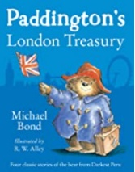  (Archaic) | The Diary of a Killer Cat by Anne Fine  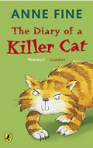  (Complexity of the Narrator) | The Hedgehog by Dick King  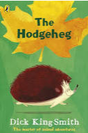  (Resistant Text) | The Enchanted Wood by Enid Blyton  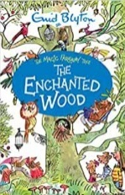  (Archaic) | Fantastic Mr Fox  By Roald Dahl  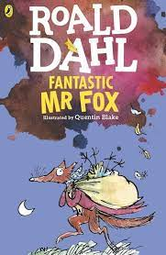  (Complexity of Narrator) | 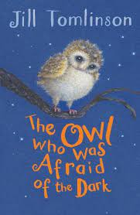  The Owl Who Was Afraid of the Dark by Jill Tomlinson  (Complexity of Plot)
English Vehicle texts | A River   | The Night Gardner  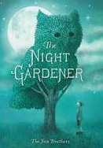 | The Bog Baby  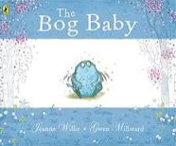 | Grandad’s Island  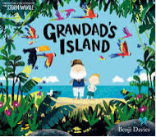 | The King Who Banned the Dark  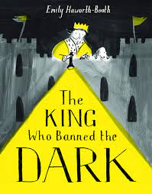 | Rosie Revere  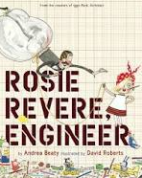
Writing outcome | 1. Narrative: Circular Narrative  2. Purpose: To narrate  Recount: Letter  Purpose: To inform | 1. Narrative: Setting Narrative  Purpose: To narrate  2. Recount: Diary  Purpose: To recount | 1. Narrative: Finding Narrative  Purpose: To narrate  2. Instructions: How to build a habitat  Purpose: To instruct | 1. Narrative: Return Narrative  Purpose: To narrate  2. Information: Jungle animals  Purpose: To inform | 1. Narrative: Banning Narrative  Purpose: To narrate | 1. Narrative: Invention Narrative  Purpose: To narrate  *
Grammar  New Learning | Co-ordination conjunctions (using and, but).  Sentence indicates its function as a statement and question.  Noun phrases for description and specification. | Co-ordination conjunctions (using and, but).  Subordination conjunctions (using when, because).  Sentence indicates its function as a statement question and command.  Noun phrases for description and specification. | Co-ordination conjunctions (using and, but, or).  Subordination conjunctions (using when, because, if).  Noun phrases for description and specification.  How the grammatical patterns in a sentence indicates its function as a statement, question and command. | Co-ordination conjunctions (using and, but, or).  Subordination conjunctions (using when, because, if, that).  Sentence indicates its function as a statement, question, command and exclamation.  Noun phrases for description and specification. | Co-ordination conjunctions (using and, but, or).  Subordination conjunctions (using when, because, if, that).  Sentence indicates its function as a statement, question, command and exclamation.  Noun phrases for description and specification. | Noun phrases for description and specification.  Co-ordination conjunctions (using and, but, or).  Subordination conjunctions (using when, because, if, that).  How the grammatical patterns in a sentence indicates its function as a question, exclamation and command.
Punctuation  New Learning | Use of capital letters, full stops and question marks to demarcate sentences.  Use apostrophes to mark singular possession in nouns. | Use of capital letters, full stops, question marks and exclamation marks to demarcate sentences.  Apostrophes to mark where letters are missing in spelling.  Commas to separate items in a list. | Use of capital letters, full stops and question marks to demarcate sentences.  Commas to separate items in a list.  Apostrophes to mark where letters are missing in spelling (contractions). | Use of capital letters, full stops, question marks and exclamation marks to demarcate sentences.  Use apostrophes to mark singular possession in nouns.  Commas to separate items in a list. | Use of capital letters, full stops, question marks and exclamation marks to demarcate sentences.  Use apostrophes to mark singular possession in nouns. | Use of capital letters, full stops, question marks and exclamation marks to demarcate sentences.  Use apostrophes to mark singular possession in nouns.  Commas to separate items in a list.
Text  New Learning |  |  | Correct choice and consistent use of past and present tense throughout writing. | Correct choice and consistent use of past and present tense throughout writing including progressive forms of verbs. | Correct choice and consistent use of past and present tense throughout writing. | Correct choice and consistent use of past and present tense throughout writing including progressive forms of verbs.
Mathematics | Number: Place Value (3 weeks)  Number: Addition (3 weeks) | Number:  Subtraction (2 weeks)  Multiplication (2 weeks)  Number: Division (2 weeks) | Number: Money (2 weeks)  Geometry: Properties of shape (2)  Fractions of shape (2 weeks) | Fractions of number (2 weeks)  Measurement: Time (2 weeks)  Position and direction (1 week)  Consolidation (1 week) | Addition (1 week)  Subtraction (1 week)  Division (1 week)  Multiplication (1 week)  Assessment – SATS (1 week) | Statistics (2 week)  Measurement: length and height (2 week)  Measurement: Mass, capacity and temperature (2 weeks)  Consolidation (1 week)
Science | Uses of everyday materials | Living things and their habitats | Habitats from around the world | Animals, including humans 1 - Growth | Animals, including humans 2 - Life cycles | Plants
History |  | Great Fire of London | Great Explorers: Robert Falcon Scott | Great Explorers: Christopher Columbus
Geography | Lost in London |  |  |  | Geography Skills and Fieldwork. | Kenya
Computing | Computing systems and networks – IT around us |  | Programming A – Robot algorithms |  | Data and information – Pictograms (Link to Maths) | Programming B - Programming quizzes
Art and Design | Craft and Design: Map it out. |  | Painting and Mixed Media: Life in colour. |  | Sculpture and 3D: Clay houses.
Design and Technology |  | Structures: Baby Bear’s Chair |  | Mechanisms: Fairground Wheel |  | Mechanisms: Making a moving monster.
P.E | Team building  Elite – Sending and receiving | Dance  Elite – Target games | Ball skills  Elite - Gymnastics | Yoga  Elite – Invasion games | Net and wall  Elite - Athletics | Swimming  Elite – Striking and fielding games
R.E | Islam: Prayer at home. | Christianity: Christmas - Jesus a gift from God. | Christianity: What did Jesus teach us? | Christianity: Easter – resurrection. | Community and belonging. | Islam: Hajj
Music | Pitch (Theme: Musical Me) | Nativity (song practice) | Instruments (Theme: Musical storytelling) | Structure (Theme: Myths and legends) | Contrasting dynamics (Theme: Space) | Call and response (Theme: Animals)
PSHE | Relationships:  - Families and Friendships  - Safe relationships  - Respecting ourselves and others |  | Living in the wider world:  - Belonging to a community  - Media literacy and digital resilience  - Money and work |  | Health and wellbeing:  - Physical health and mental wellbeing  - Growing and changing  Keeping safe

