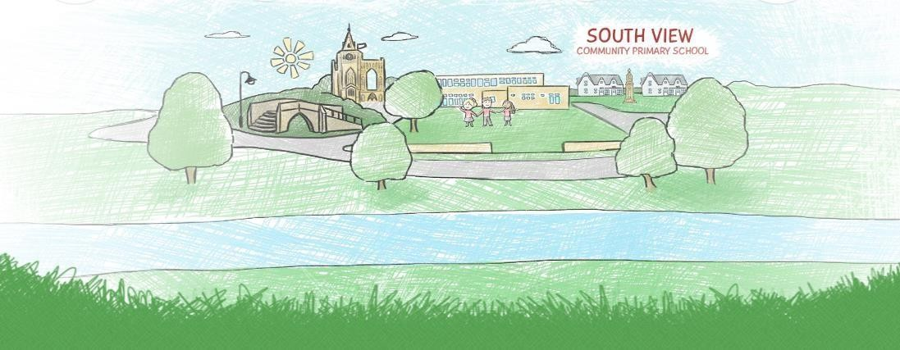


South View Community Primary School and Preschool

Parent and Visitor

Code of Conduct

Last reviewed: September 2025 Reviewed by: Standards/FGB Next review due: October 2026 Advisory
School Policy

1

PARENTS, CARERS and VISITORS CODE OF CONDUCT
Introduction
We are very fortunate to have many supportive and friendly parents/carers. We want our parents/carers to recognise that educating children is a process that involves partnership between parents, class teachers and the School community as a whole.

As a partnership, our parents/carers should understand the importance of a good working relationship to equip children with the necessary skills for childhood and adulthood. For these reasons, we continue to welcome and encourage parents/carers and visitors to participate fully in the life of our Preschool and School.

Parental engagement with their children's learning is important in supporting attainment and progress and parents have a legitimate right to understand what their child is learning at Preschool and School.

However, contact between parents/carers and the Preschool, School and out of School wraparound care (Orchards) must be appropriate, proportionate and respectful, both of the professional knowledge, experience and skill of the staff and of the entitlement of staff to some work/life balance.

Purpose
The purpose of this policy is to provide a reminder to all parents, carers and visitors to our School about the expected conduct. This is so we can continue to flourish, progress and achieve in an atmosphere of mutual understanding.
The policy sets out:
- The general principles underpinning the conduct of members of the School community.
- How it is expected that communication between parents/carers and the School will take place.
- What behaviour towards the School and members of the School community are deemed unacceptable and open to challenge by the School.
- The additional steps the School can take in respect of unacceptable behaviour by a parent, carer or visitor.

General Principles
- Remember that Preschool, School and Orchards is governed by the School rules as decided upon by the Governing Body of the School and the Senior Leadership Team.
- Respect the caring ethos and values of our Setting.
- Understand that staff and parents need to work together for the benefit of their children.
- Demonstrate that all members of the School community should be treated with respect and therefore set a good example in their own speech and behaviour.

Communication
There are many reasons you might want to communicate with the School or a member of staff. This could be simply phoning in to report a child's absence or informing a member of staff when you drop your child off that they have forgotten something or have been complaining of feeling a little unwell. These short conversations to impart information are entirely necessary.
However please remember:
- How busy members of staff are during the day, particularly first thing in the morning. If you need to speak with a member of staff for something more substantial, please make an appointment to do so at a time when they can give you their full attention.
- Approach the Preschool or School to help resolve any issues of concern by making an appointment to meet with the key worker/class teacher in the first instance. In the second instance you would speak with the key worker/teacher’s line manager, which in our School is the head teacher.
- If the matter is still not resolved follow the procedure in the School's Complaints Policy which is available under the heading "policies" on our website.
- If you wish to correspond by email this should be done through the central email address at enquiries@southview.lincs.sch.uk or ???? This address is monitored regularly during the School day and emails forwarded to the appropriate member of staff or Governor.
- Ensure that all such communications are polite and that you are always mindful of the right of the recipient to be treated with respect.
- When meeting face to face with members of staff to discuss any matters concerning your child's education or wellbeing, approach the matter calmly and politely, as this will also ensure progress can be made to address any issues or concerns. Remember, if you wish to speak with a member of staff it will normally fall to you to make a mutually convenient appointment.

Unacceptable Behaviour
- Contacting staff or members of the Governing Body out of hours using their individual email addresses rather than the School contact email address above. Staff and Governors are entitled to their own personal and family time.
- Do not send any form of correspondence to members of staff or Governors at the School demanding an immediate response or a response within your own time frame as the matter will be addressed, where appropriate, in a time frame deemed appropriate by the recipient.
- Send lengthy, frequent, demanding, or disrespectful emails to staff members as this will seriously undermine their ability to carry out their core role of caring for and educating the children.
- When corresponding or speaking with staff in person do not use language that calls in to question their professional abilities or represents any form of personal attack, nor should you seek to direct how they carry out their professional roles or run the School. The running of the Preschool, School and Orchards is a matter for the Senior Leadership Team and the Governing Body of the School.
- It is unacceptable to record telephone conversations with staff members or to record meetings with staff and/or Governors at the School without making them aware you are doing so and seeking their express permission to capture what could be their personal information and breach their human right to privacy which extends to their workplace.
- Resort to any other form of criticism of the School, its staff or Governing Body or any other matters that relate directly to the School via a medium other than the Schools complaints policy and parents and carers are asked to be aware of the Settings "social media policy" as it appears in "Appendix A".
- When speaking with a staff member or any other member of the School community whether in person, on the telephone or by any other means of communication, it is entirely inappropriate to raise your voice, invade their personal space, use language that is disrespectful, rude, offensive, aggressive or threatening.
- Do not shout, swear or cause any form of disruption on the premises.
- Any threats of violence or use of violence towards anyone on the premises is a criminal offence, as is damage to the premises, will be likely to result in the matter being reported to the police.
- Do not smoke or consume alcohol or other drugs on any part of the premises.
- Do not bring dogs onto the premises unless the dog is a guide dog or other form of assistance dog.
- Avoid using staff as threats to reprimand children’s behaviour.
- Approaching someone else’s child in order to discuss or chastise them because of the actions of this child towards their own child. Such an approach to a child may be seen to be an assault on that child and may have legal consequences.
- Do not use disruptive behaviour which interferes or threatens to interfere with the operation of a classroom, an employee’s office, office area or any other area of the premises.

Additional Steps by the Setting
- The member of staff or Governor concerned may challenge the behaviour by asking the person concerned to respect their personal space, stop shouting or using inappropriate behaviour or may end an unacceptable phone call or ask you to leave the premises.
- The Setting may correspond in writing with a parent or carer to challenge behaviour, that is unacceptable such as, for example, being rude to a member of staff or sending too many emails making demands.
- If the Setting decide the matter requires a more formal approach, the Setting may instruct its legal advisers to write to the parent or carer warning them about their behaviour and/or putting in place a communications strategy to restrict their means of corresponding with the Setting and/or banning them from Setting premises if felt to be appropriate. This could include banning visitors to the premises who are deemed to be a safeguarding risk because of their actions and behaviours in the wider community.
- Clearly, in serious instances where the peace is breached or the criminal law broken the Setting will also involve the police.
Please note that Setting premises are not public places but private premises and you have an implied right to enter the Setting as a parent or carer of a child at the Preschool or School, but it is open to the Setting to remove that right of entry at any time it deems this to be necessary.
We trust that parents and carers will assist our Setting with the implementation of this policy and we thank you for your continuing support.
Note: Could parents please ensure they make all persons responsible for collecting their children aware of this policy.

Appendix 1: Inappropriate use of Social Network Site
Social media websites are being used increasingly to fuel campaigns and complaints against Preschools, Schools, Head Teachers, School staff, and in some cases other parents/pupils.
The School seeks to teach pupils the importance of appropriate and responsible use of social media. It is therefore vital that everyone in the Setting’s community, including parents, carers and visitors lead by example.
The Governors considers the use of social media websites to complain about the Setting or individual members of staff or make personal comments about anyone in the Setting community is unacceptable and not in the best interests of the children or the whole School community. Any concerns you may have must be made through the appropriate channels using the Settings Complaints Policy by speaking to the key worker, class teacher, the Head Teacher or the Chair of Governors, so they can be dealt with fairly, appropriately and effectively for all concerned in line with that policy. In the event that any student or parent/carer of a child/ren being educated in the Setting is found to be posting libelous or defamatory comments on any social network sites, they will be reported to the appropriate 'report abuse' section of the network site.

All social network sites have clear rules about the content, which can be posted, on the site and they provide robust mechanisms to report contact or activity which breaches this. The Setting will also expect that any parent/carer or student removes such comments immediately.

In serious cases, the Setting will also consider its legal options to deal with any such misuse of social networking and other sites. Additionally, and perhaps more importantly is the issue of cyber bullying, and the use by one child or a parent to publicly humiliate another by inappropriate social network entry. We will take and deal with this as a serious incident of School bullying. Thankfully such incidents are extremely rare.
Please note that the inappropriate use of a communications network can give rise to offences under the Malicious Communications Act 1988 or the Communications Act 2003 and if persistent could be deemed to constitute the offence of harassment.

